Sampling Spoon
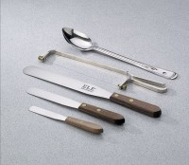 | Sampling Spoon  Code: 88-7700  Attributes: Description = Sampling Spoon  Standards:

