Vicat Method
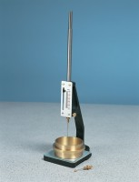 | Vicat Frame  Code: 38-2010  Attributes: Description = Vicat Frame (less Needle Sets and Moulds), Weight, kg = 1.3  Standards: EN 196-3, EN 13454-2, ASTM C187, ASTM C191

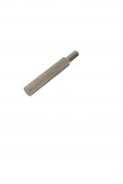 | Consistency Plunger  Code: 38-2010/10  Attributes: Description = Consistency Plunger  Standards: EN 196-3, EN 13454-2, ASTM C187, ASTM C191

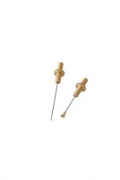 | EN Initial and Final Set Needle  Code: 38-2110  Attributes: Description = EN Initial and Final Set Needle, Weight, kg = 0.018  Standards: ASTM C187, ASTM C191

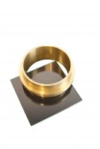 | Vicat Mould  Code: 38-2200  Attributes: Description = Vicat Mould  Standards: ASTM C187, ASTM C191

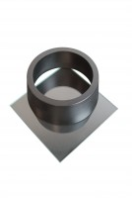 | EN Vicat Mould  Code: 38-2300  Attributes: Description = EN Vicat Mould  Standards: EN 196-3

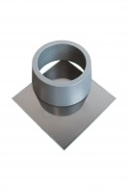 | ASTM Vicat Mould  Code: 38-2660  Attributes: Description = ASTM Vicat Mould  Standards: ASTM C187, ASTM C191

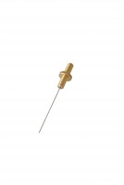 | ASTM Initial Set Needle  Code: 38-2620  Attributes: Description = ASTM Initial Set Needle  Standards: ASTM C187, ASTM C191

