Guelph Permeameter
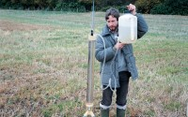 | Guelph Permeameter Supplied Complete with Extension Kit.  Code: 25-0650  Attributes: Description = Guelph Permeameter, Hydraulic Conductivity Range, m/sec = 10-4 - 10-8  Standards: ASTM D5126

