Harvard Mechanical Trip Balance
 | Plastic Scoop and Counterweight  Code: 78-7130  Attributes: Description = Plastic Scoop and Counterweight  Standards:

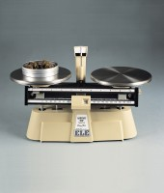 | Harvard Trip Balance  Code: 78-7090  Attributes: Description = Harvard Trip Balance, Specific Gravity = Equipped for specific gravity weighing (components not included, order separately)  Standards:

Weights for Harvard Trip Balance
Code: 78-7110
Attributes: Description = Weights for Harvard Trip Balance
Standards: ASTM class 6

