Standard Muffle Furnace
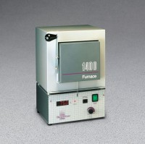 | Standard Muffle Furnace  Code: 88-0110/02  Attributes: Description = Standard Muffle Furnace, Temperature Range, °F = 1799.6 - 2012  Standards:

