Sample Mixers
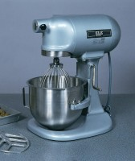 | Bench-Mounting Mixer 4.7Litre Capacity Complete with Bowl Beater and Whisk. 220-240V 50Hz 1Ph.  Code: 23-6191/01  Attributes: Description = Bench-Mounting Mixer, Voltage Supply = 220 - 240 V AC, 50 Hz, 1ph  Standards: BS 598-107, BS 1377-1, BS 1924-1

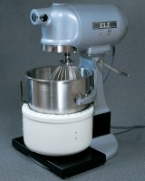 | Isomantle Electric Heater  Code: 45-5580/01  Attributes: Description = Isomantle Electric Heater, Voltage Supply = 220 - 240 V AC, 50/60 Hz, 1 ph  Standards: EN 12697-35

 | Stainless Steel Bowl 4.73 Litres.  Code: 23-6191/10  Attributes: Description = Stainless Steel Bowl  Standards:

