Scoops and Shovels
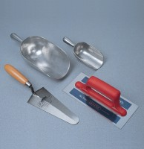 | Aluminium Scoop Small  Code: 81-0200  Attributes: Description = Small Aluminium Scoop  Standards:

Aluminium Scoop Large
Code: 81-0220
Attributes: Description = Large Aluminium Scoop, Weight, kg = 0.294 kg
Standards:

Scoop - 250 mm long
Code: 81-0222
Attributes: Description = Stainless Steel Scoop, Capacity, litres = 5 kg
Standards:

Shovel - With flat blade
Code: 81-0240
Attributes: Description = Flat Blade Shovel, Weight, kg = 3
Standards:

