Spares
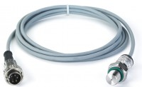 | Pressure transducer, 0-700bar, 0.05 to 10v DC Output  Code: 6014A0062  Attributes: Description = Pressure transducer  Standards:

