Yield Buckets
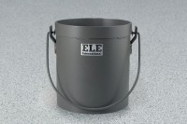 | Yield Buckets 1/10 cu. Ft. Capacity  Code: 34-2860  Attributes: Capacity, g = 1/10, Description = Yield Buckets 1/10 cu. Ft. Capacity  Standards: ASTM C138, AASHTO T121

Yield Buckets 1/2 cu. Ft. Capacity
Code: 34-2862
Attributes: Capacity, g = 1/2, Description = Yield Buckets 1/2 cu. Ft. Capacity
Standards: ASTM C138, AASHTO T121

