Load Measurement
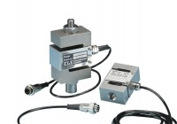 | S-Type Load Cell 5 kN.for Use with Direct/ Residual Shear Machine. Fitted with 5 Pin Din Plug.  Code: 27-1561  Attributes: Description = S-Type load cell, Force Capacity, kN = 5, Environmental Protection = IP65  Standards: BS 1377, ASTM D3080

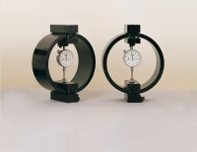 | Clamped Boss Load Ring - 4.5 kN  Code: 78-0260  Attributes: Description = Load ring - 4.5 kN, Load device type = Load ring, Force Capacity, kN = 4.5, Weight, lbs = 9.25  Standards:

