Asphalt Centrifuge Extractors
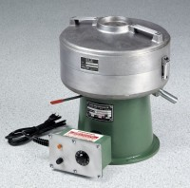 | Centrifuge Extractor 1,500 g  Code: 45-3820/02  Attributes: Description = Centrifuge Extractor 1,500 g  Standards: ASTM D2172, AASHTO T164

Centrifuge Extractor 3,000 g
Code: 45-3825/02
Attributes: Filter Discs = 10, Description = Centrifuge Extractor 3,000 g
Standards: ASTM D2172, AASHTO T164

 | Filter Discs for 1,500 g  Code: 45-3840  Attributes: Description = Filter Discs for 1,500 g  Standards:

Filter Discs for 3,000 g
Code: 45-3842
Attributes: Description = Filter Discs for 3,000 g
Standards:

Biodegradable Solvent
Code: 45-3845
Attributes: Description = Biodegradable Solvent
Standards:

