Additional Analog Proving Rings
 | Proving Ring, 2,000 lbs  Code: PR-20  Attributes: Description = Proving Ring, 2,000 lbs  Standards:

Proving Ring, 6,000 lbs
Code: PR-60
Attributes: Description = Proving Ring, 6,000 lbs
Standards:

Proving Ring 10,000 lbf Capacity
Code: PR-100
Attributes: Description = Proving Ring 10,000 lbf Capacity
Standards:

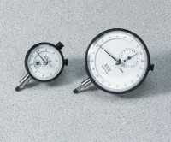 | Mechanical Dial Indicator - 0.2" Range  Code: 88-4000  Attributes: Movement = Clock, Description = Mechanical Dial Indicator - 0.2″ Range  Standards:

