10 kN Flexural/ Tensile Testing Machine
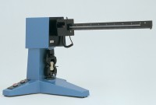 | 10kN Flexural/Tensile Testing Machine  Code: 39-7100/01  Attributes: Description = 10 kN Flexural/Tensile Testing Machine, Power Supply = 220 - 240 V AC, 50 Hz, 1 ph  Standards: EN 196-1

