Hot Plates
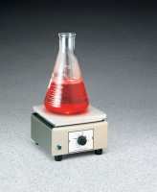 | Hot Plate  Code: 88-0500/02  Attributes: Description = Hot Plate 39 sq. in.  Standards:

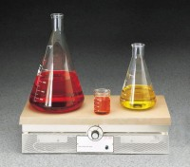 | Hot Plate 288 sq. in.  Code: 88-0530/02  Attributes: Case = Stainless steel., Description = Hot Plate 288 sq. in.  Standards:

