Combination Permeameter
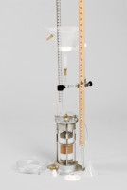 | Combination Permeameter  Code: 25-0623  Attributes: Description = Combination permeameter, Falling Head = Graduated pipette; 100 cc x 0.2 cc; 100 cm. maximum<br>head.  Standards:

