Vacuum Pyknometer (2,000 Gram)
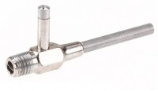 | Aspirator Type Filter Pump  Code: 45-9311  Attributes: Description = Aspirator Type Filter Pump  Standards:

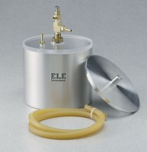 | Vacuum Pyknometer (2,000 gram)  Code: 45-9310  Attributes: Description = Vacuum Pyknometer (2,000 gram)  Standards: ASTM D2041, AASHTO T209, AASHTO T283

 | Drierite Desiccant  Code: 45-9315/14  Attributes: Description = Drierite Desiccant  Standards:

