Horizontal Sample Ejector
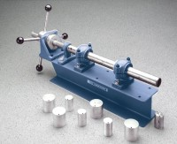 | Horizontal Sample Ejector  Code: 23-1370  Attributes: Weight, lbs = 130, Description = Horizontal Sample Ejector  Standards:

