Field CBR
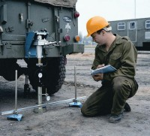 | Field CBR Test Set, English  Code: 2400E  Attributes: Weight, lbs = 137.8, Description = Field CBR Test Set, English  Standards: ASTM 4429

Field CBR Test Set, Metric
Code: 2401E
Attributes: Weight, lbs = 137.8, Description = Field CBR Test Set, Metric
Standards: ASTM 4429

